Adobe Connect Client Installation Instructions

Installation
- Ctrl+Click the following link: http://www.adobe.com/go/Connectsetup

- Your internet browser will open and a prompt to run ConnectSetup.exe will appear at the bottom of the window. Click Run.

- An Adobe Connect Installer will open. Click Install to begin the installation process.
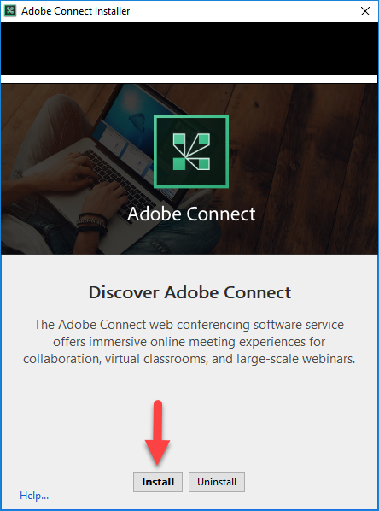

- Once the Adobe Connect Installer is complete, make your shortcut selections and click Exit. The Adobe Connect Client is now installed and the Adobe Connect Installer will disappear. You can now close the previously opened browser window.
