Using Zoom for College of Central Florida Meetings

Think of Zoom as a virtual room. You will receive an email with an invitation to discuss your enrollment or financial aid needs. You can join zoom via computer, tablet, or smart phone.

- When you click on the link, Zoom launches the software (which takes 30-60 seconds).

- The person who sent you the invitation is the host, you will be a participant. The host may share materials with you, or ask you to share materials needed for the processing of your application.

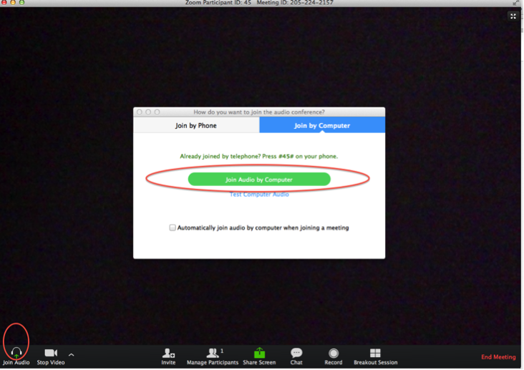

- This is a view from a computer, laptop, or tablet. Let’s work from left to right on the icons/controls above. By the way, you only see controls when your mouse hovers across the bottom of the screen. Otherwise, they’re invisible!

  - Mute – this mutes YOUR audio. The upward “carrot” to the right lets you choose what microphone and speakers will be used.

  - Stop Video. This allows the use of the webcam, or turns off your webcam/image.
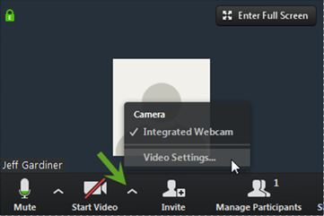
  - Invite – This is what your host may use to invite you or others to a zoom room.

  - Manage Participants – This lists participants. When you click on this, a box opens:
    - You can use this view on your name to change the name that appears in zoom when using a computer or smart device.
    - If your host has voting and nonverbal reactions enabled, clicking on “participants” will give you access. If you are using your phone, click on your picture and select your options.

  - Share Screen – (Only if instructed by the host or presenter.) Close every application except what you need. This icon will open up all active software on your computer; then choose what you want to share.

  - Chat – You can chat with the host or others in your Zoom meeting; the window can be moved or resized.

  - Record link – This is not an option as recorded sessions are deleted!

  - Leave Meeting – In the lower right corner of Zoom, you will see end the meeting. Only the host may end the meeting. You will see Leave Meeting at the bottom right. Participants will leave a meeting by selecting the “leave” option.

- Views – The view link is in the upper right corner of the screen. It appears when two or more participants are present in the Zoom room and you hover your mouse over it. It lets you choose between a big view of the presenter/little view of participants, or equal size windows of all.

Gallery view – Participants are equal size; the person talking is highlighted in yellow. The window size shrinks as the group grows. Click in upper right to go to Speaker View.

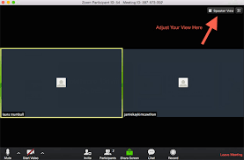

Speaker View – The host or speaker is featured, participants are in thumb nail. To go to Gallery View, click the box in the upper right corner.

Toggle Views – When someone shares a screen, you can toggle between a large view of the shared screen, or the participants. See the icon in upper right, a box in a box.

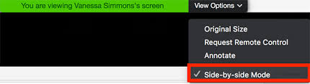
**The annotate option allows you to interact with the presenter’s white board or document, if you are given permission.**

- A limited number of people appear on screen (9 - 12), even if there are more in zoom. Cell phones allow you to see four people per screen.

- For information on ZOOM, please visit: https://support.zoom.us/hc/en-us/articles/360034967471-Quick-start-guide-for-new-users

